
MATHEMATICS DEPARTMENT
Year 11 Specialist – 2016
Test Number 4:
Combinations and Circle Geometry
Resource Rich
Total Mark
/47
Name: _______________________________________ Teacher: DDA
Marks: 47
Time Allowed: 45 minutes
Weight: 5%
Instructions: You permitted 1 A4 page of notes and your calculators. Show your working where appropriate remembering you must show working for questions worth more than 2 marks.
_________________________________________________________________________
Part A
5 multiple choice questions
5 marks
1 Counting the 1 at the top as row 0, what is the fifth number on row 9 of Pascal’s triangle?
A 126
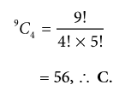
B 70
C 56
D 120
E 210

[1 mark]

2 In the diagram, O is the centre of the circle. The value of ∠ACB is:
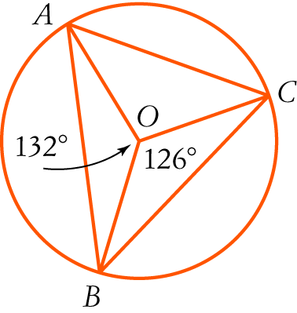
ACB = 66°, (angle at the centre is twice angle at circumference standing on arc AB,∴ C.
A 24°
B 27°
C 66°
D 63°
E 39°

[1 mark]

3 The size of ∠VTU in the diagram is:
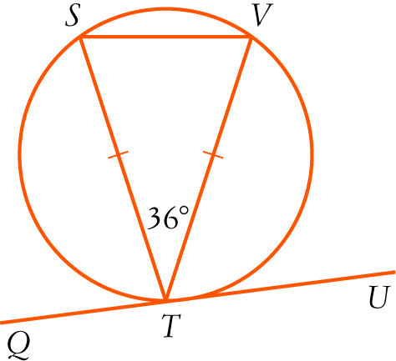
VST = 72° (base angles equal, angle sum of isosceles ∆ VST), ∠VTU = 72° (angle between the
chord and the tangent equals the angle in the alternate segment), ∴ A.
A 72°
B 54°
C 36°
D 18°
E 90°

[1 mark]

4 The value of x in the diagram is:
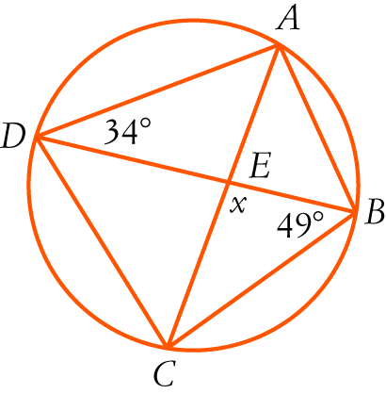
∠ACB = 34° (angles standing on arc AB) x = 97 (angle sum of triangle), ∴ E.
A 83°
B 68°
C 98°
D 96°
E 97°

[1 mark]
5 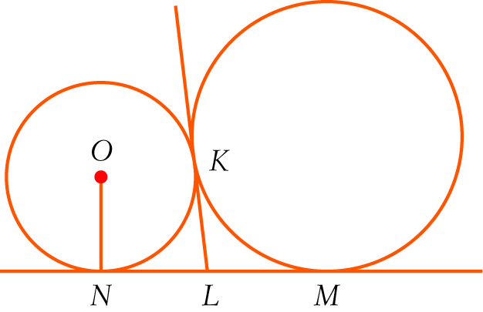
In the diagram, NM is a common tangent to the circles. KL is also a common tangent and O is the centre of the smaller circle.
Consider the statements:
I LN = NO II KL = LN III LN = LM
Which of the statements are true?
A I and II
B I, II and III
∠ Tangents drawn from a common external point are equal, so KL = LN and KL = LM, so LN = LM, ∴ C.
C II and III
D I and III
E None of the above.

[1 mark]

Part B
8 short answer questions
32 marks
Show your working where appropriate.
6 nC6 = 7 × nC4. Solve for n.
$$\frac{n!}{\left(n-6\right)!6!}=7×\frac{n!}{\left(n-4\right)!4!}$$

$$\frac{1}{\left(n-6\right)!6×5×4!}=\frac{7}{\left(n-4\right)\left(n-5\right)\left(n-6\right)!4!}$$

$$\left(n-4\right)\left(n-5\right)=210$$
$$n^{2}-9n-190=0$$
$$\left(n+10\right)\left(n-19\right)=0$$
$$n=-10 or 19 but n>0 ∴n=19$$

[5 mark]
7 There is only one black jelly bean in a packet with 20 left in it.
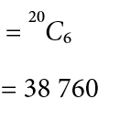
a How many different selections of 6 jelly beans are possible?

b How many selections include the black one?
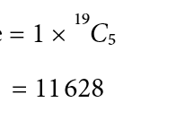

[4 marks]

8 A class has 24 students. Of these students, 9 do not do any of Physics, Chemistry or Computer Science. There are 6 who do Physics and Chemistry, 4 who do Physics and Computer Science and 5 who do Chemistry and Computer Science. There are 11 Computer Science students, 8 who do Physics and 8 who do Chemistry. Use the inclusion-exclusion principle to find how many do all three of Physics, Chemistry and Computer Science?

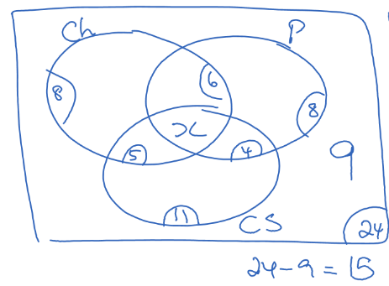
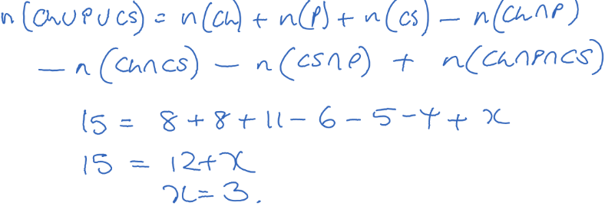

[5 marks]
9 What is the probability of getting exactly 2 faulty switches if you take 5 switches from a box of
12 switches with 4 faulty ones in it?

Number ways of getting 2 faulty switches and 3 good switches = 4C2 × 8C3 = 336
Number ways of getting 5 switches = 12C5 = 792
P(2 faulty switches) = = 0.$\overline{42}$

[3 marks]

10 In the diagram, DF = 6 cm and OE = 4 cm.
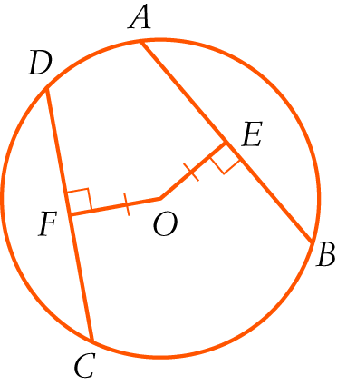
a Find the length of AB giving reasons.
AB = 12 [1 mark]
(DC = AB, chords equidistant from centre of circle are equal in length), [1 mark]
(DC = 2 DF, line through centre of circle perpendicular to chord bisects chord) [1 mark]
b Find the radius of the circle in exact form.
OD 2 = OF 2 + DF 2 r 2 = 62 + 42 [1 mark]
cm [1 mark]

[5 marks]
11 Find the value of x in surd form, giving reasons.
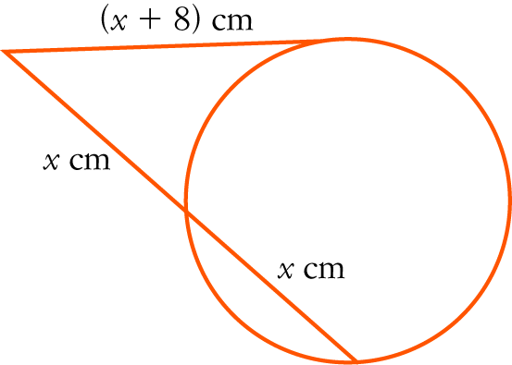
(x + 8)2 = x(x + x) (the square on the tangent equals the product of the intercepts of the
intersecting secant) [1 mark]
x2 + 16x + 64 = 2x2
x2 − 16x − 64 = 0 [1 mark]
x=8$±8\sqrt{2}$ [1 mark]
x>0 so x=8$+8\sqrt{2}$ [1 mark]
[4 marks]

12 In the diagram, AB is a diameter of the larger circle with centre C and A is the centre of the smaller circle.
The circles intersect at D. Explain why BD is a tangent to the smaller circle.
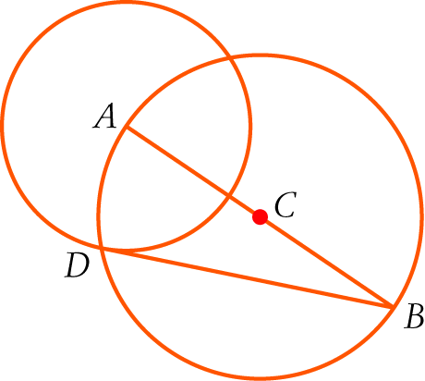
ADB = 90° (angle in a semicircle.) [1 mark]
∴ AD $⊥$ BD but AD is a radius of the smaller circle. [1 mark]
∴ BD is a tangent (tangent meets radius at right angles) [1 mark]

[3 marks]
13 Find the value of x, giving reasons.
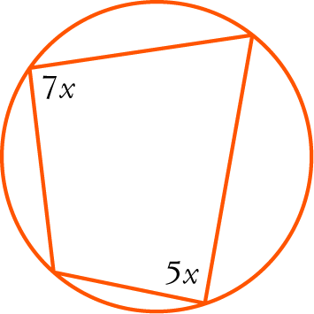
7x + 5x = 180 [1 mark] (opposite angles in cyclic quadrilateral are supplementary.) [1 mark]
∴ x = 15 [1 mark]

[3 marks]

Part C
2 analysis questions, 10 marks. Show your working where appropriate.
14 The ninth number of a row of Pascal’s triangle is half of the eighth number in the row. What is next (tenth) number in the row?
Ninth number in row n = nC8 = [1 mark]
Eighth number in row n = nC7 = [1 mark]
Thus [1 mark]
So
So n = 11 [1 mark]
The tenth number in the row is 11C9 = 55 [1 mark]

[5 marks]
15 In the diagram, TR = TS. Prove that PQ = PR.
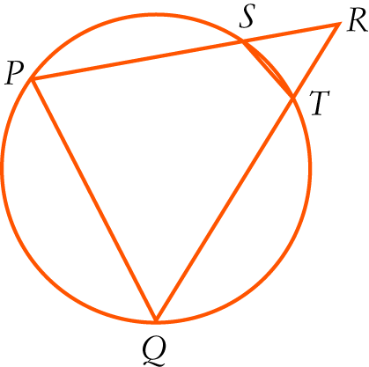
TSR =TRS (base angles of isosceles triangle) [1 mark]
Now ∠PQR = ∠TSR [1 mark] (exterior angle of cyclic quadrilateral = interior opposite angle) [1 mark]
$∴$∠PQR = ∠TRS (both = ∠TSR) [1 mark]
PQ = PR (sides opposite equal angles in triangle are equal) [1 mark]

Alternate Proof:
In $∆SRT \& ∆QRP$
$$∠SRT=∠QRT \left(common\right)$$
$$∠RST=∠RQP (exterior ancle of cylic quad=interior opposite angle)$$
$∴∆SRT \sim ∆QRP$ (AA) [2 marks]
$∴\frac{TS}{PQ}=\frac{TR}{PR} (ratio of corresponding sides of similar ∆equal)$ [1 mark]
$∴PQ=PR (since TS=TR \left(given\right))$ [2 marks]

[5 marks]

